**Network Architecture Project 1**

***Harini Reddy Anumandla***

***ID: 16301823***

**Part I. Socket programming - Develop simple TCP client and server programs locally, but test with another machine (eg: Another machine in UMKC network). Show the screenshots of simple message exchanges.**

**a) Start from client message ‘Hello from Client-your names’ and server responses with ‘Hello from Server-your names’. Then messages from each side are echoed to each other. The program quit the program with typing ‘Bye from Client-your name’ and ‘Bye from Server-your name’.**

**Server Code**

>> File name: socketserver.py

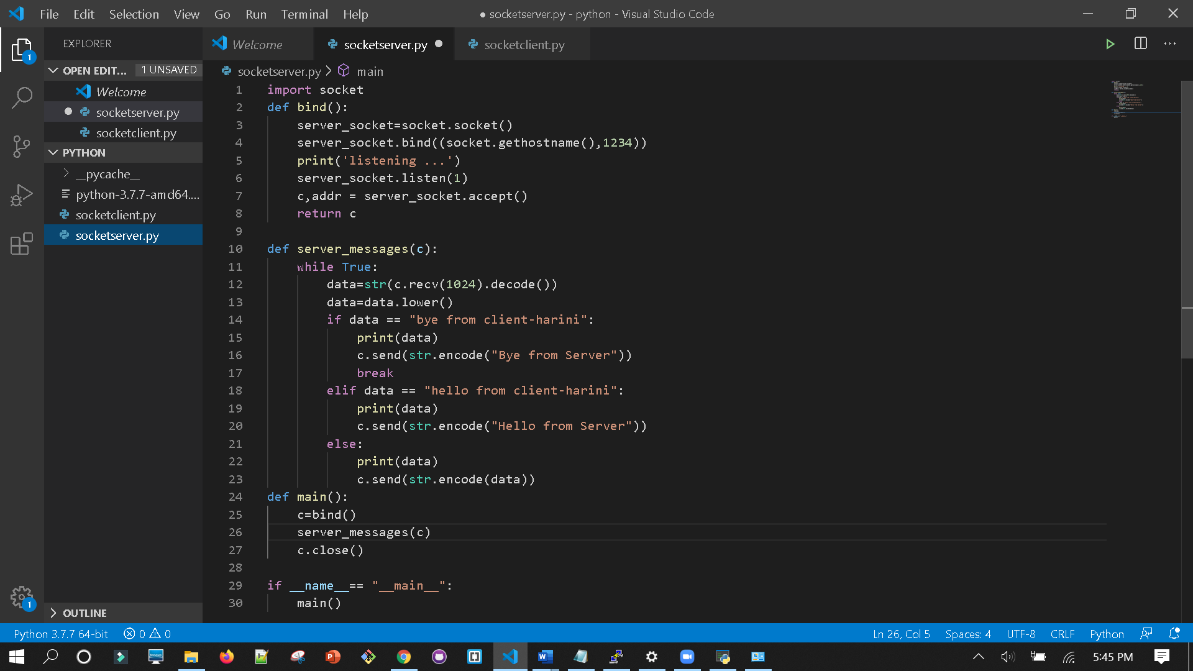

**Client code**

**>>**file name: socketclient.py

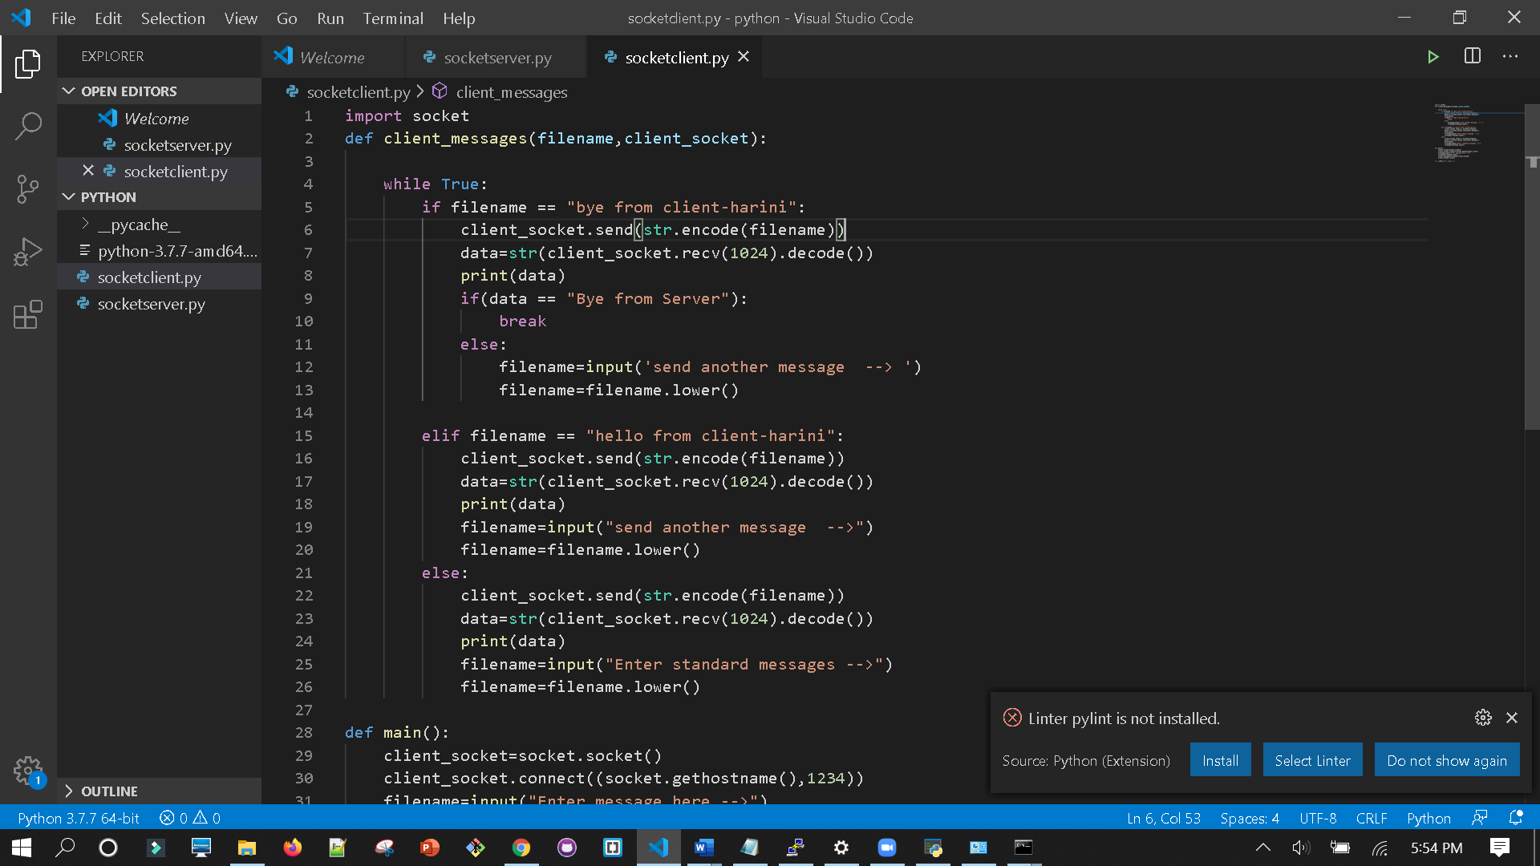

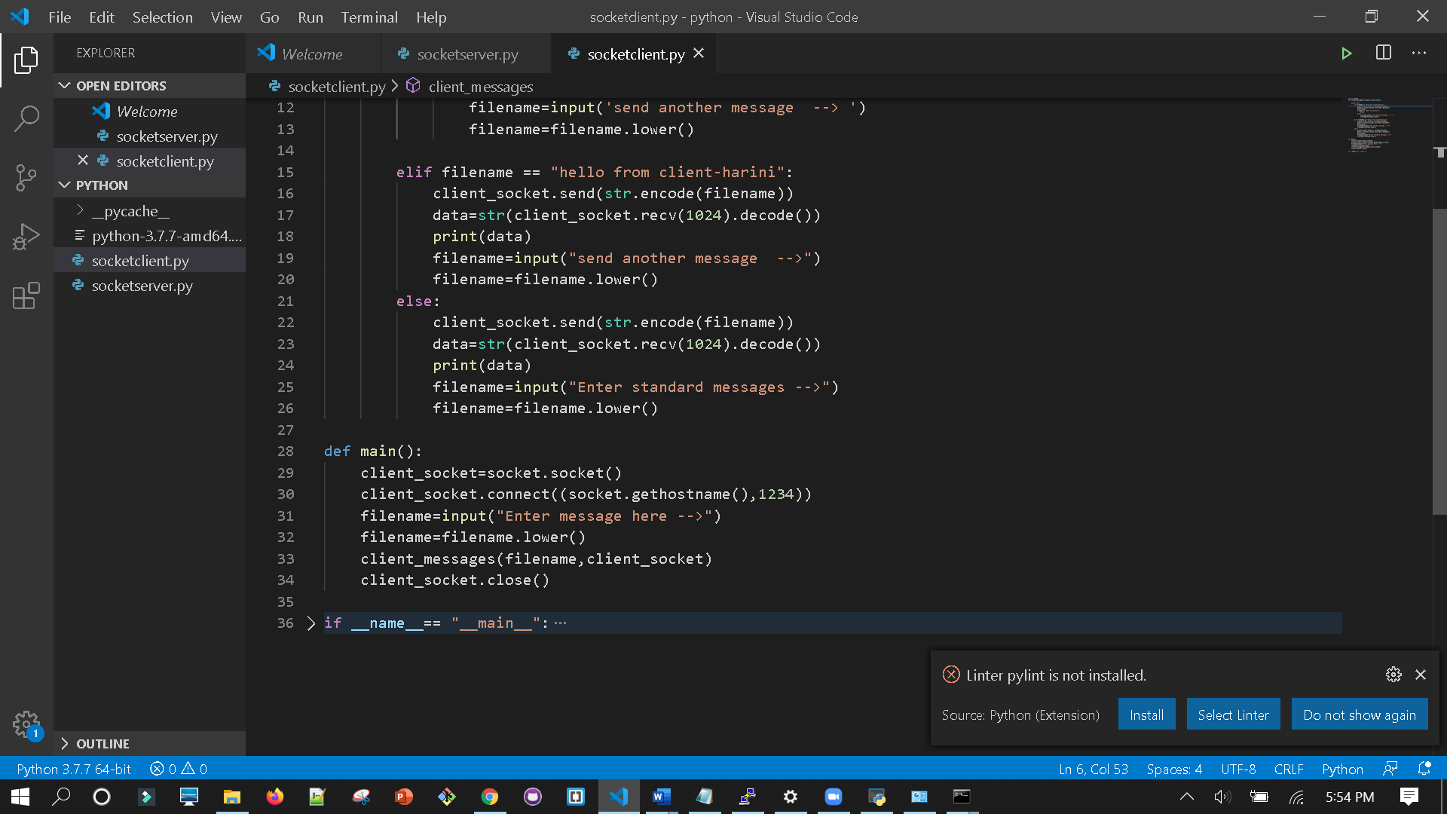

First run the server code. This will put server in listening state

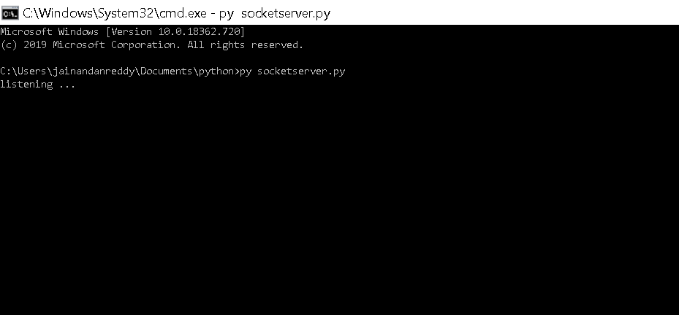

Now run the client code. We can see client-server communication here.

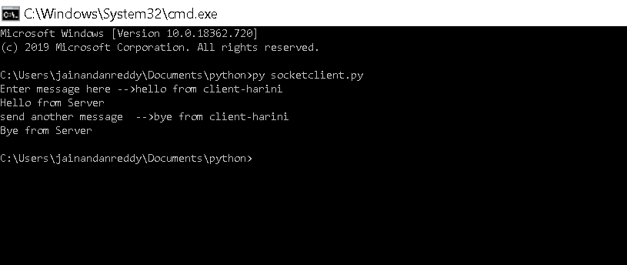

**b) A client sends a large text file (> 3 MB) to a server. (A small file transfer will receive only a partial credit Server prints the file on the screen, Server saves the file in a local system, Server appends one more line (eg. ‘This is an added line from a server) to the file. And send the updated file back to the client. Client shows the file on the screen after it fully receives the file. And display the newly added lines from the server, not the entire file content**

>>**” input.txt”** is the large text file which is 104333KB = 10.1 MB

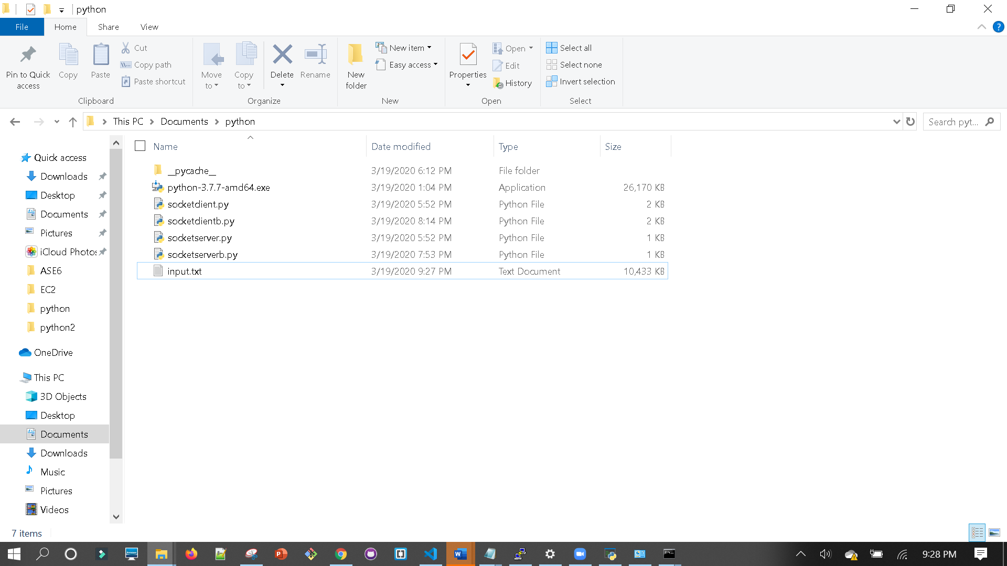

**Server Code**

>>File name socketserverb.py

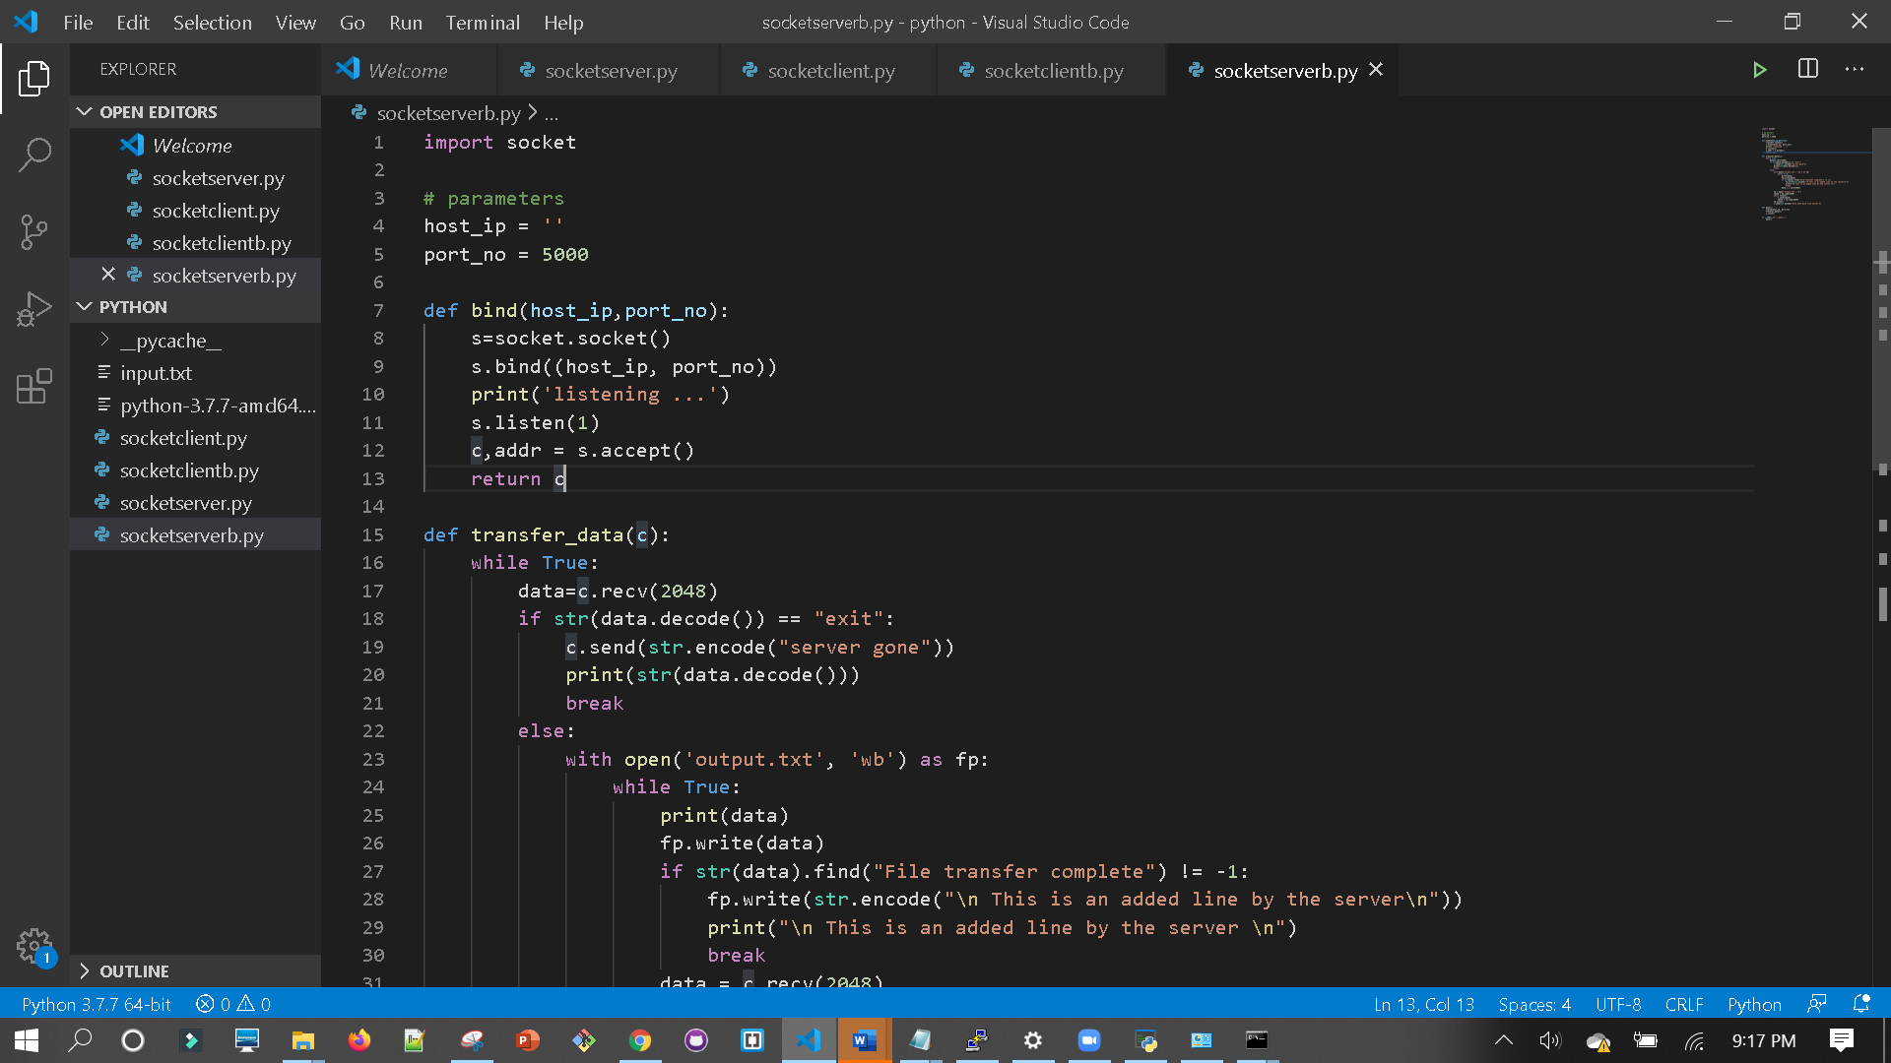

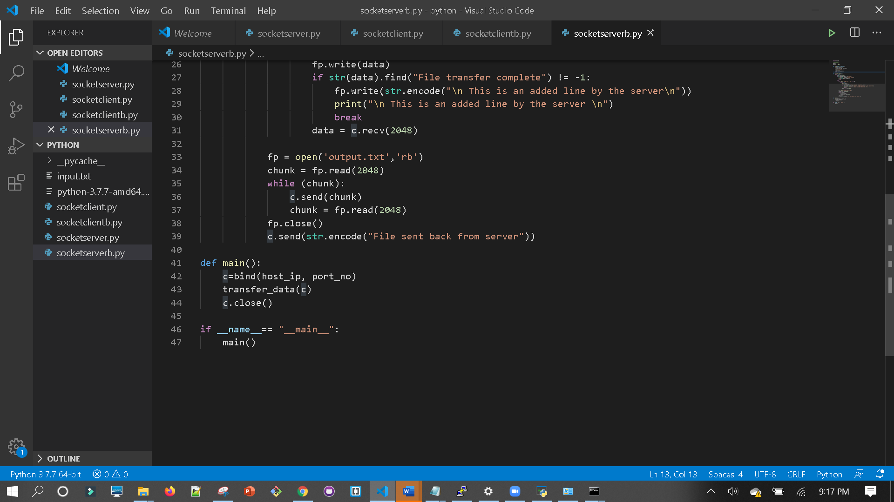

**Client code**

>>file name: socketclientb.py

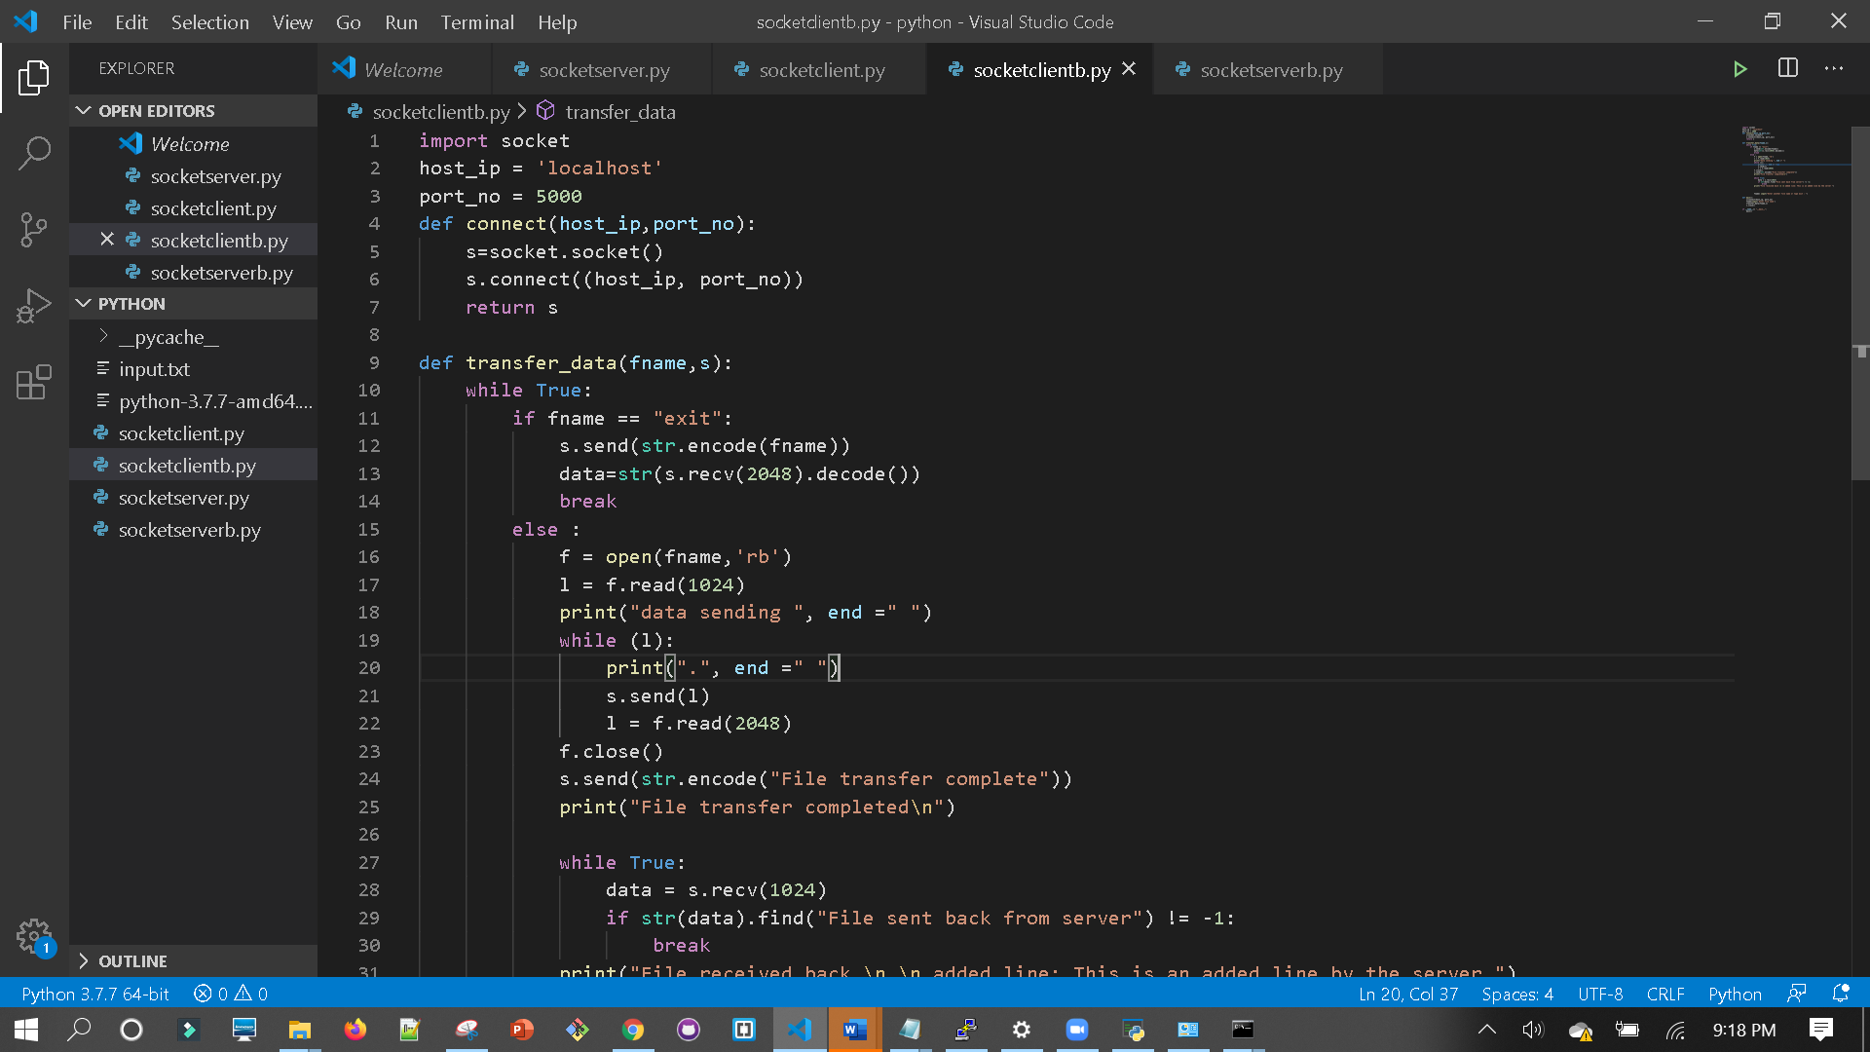

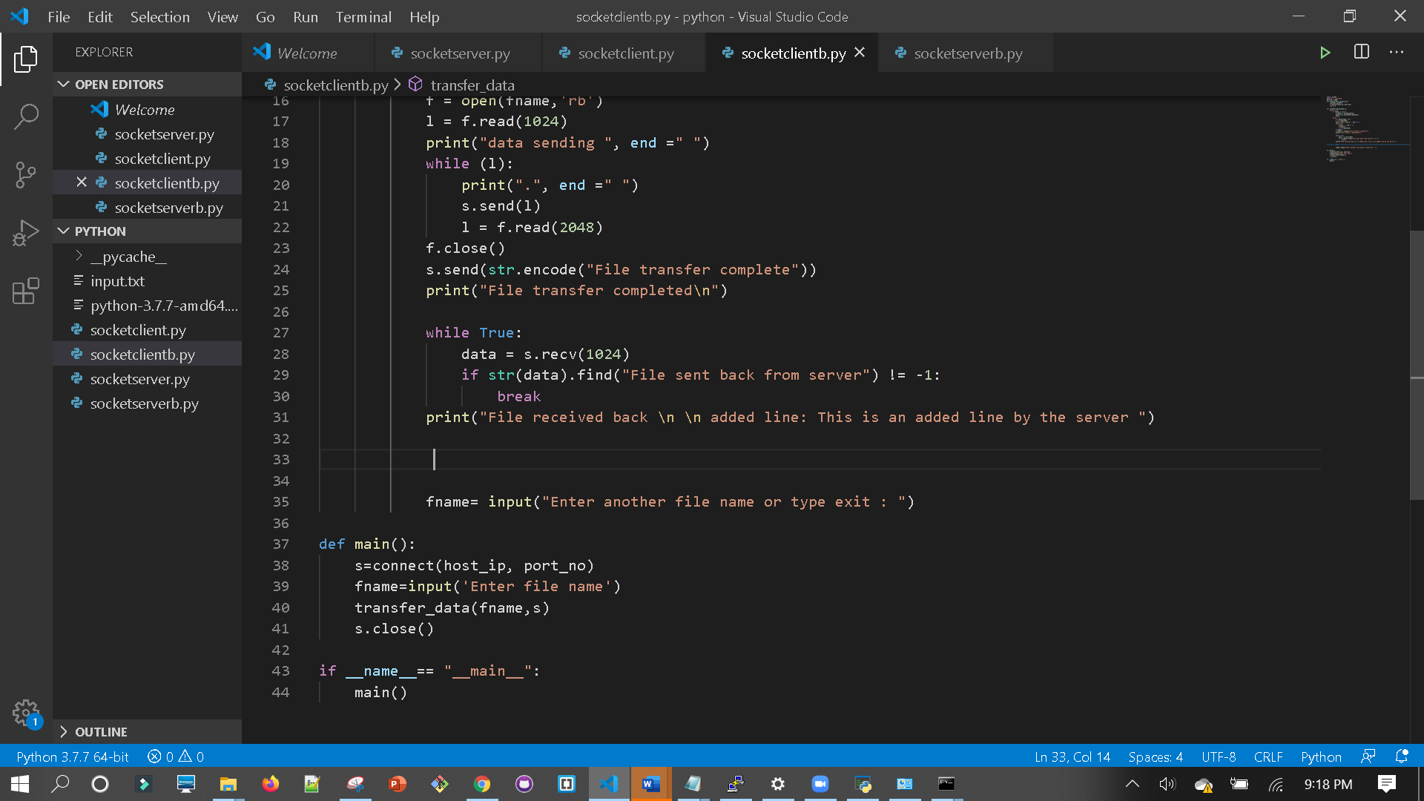

>>First run the server code. This will put server in listening state

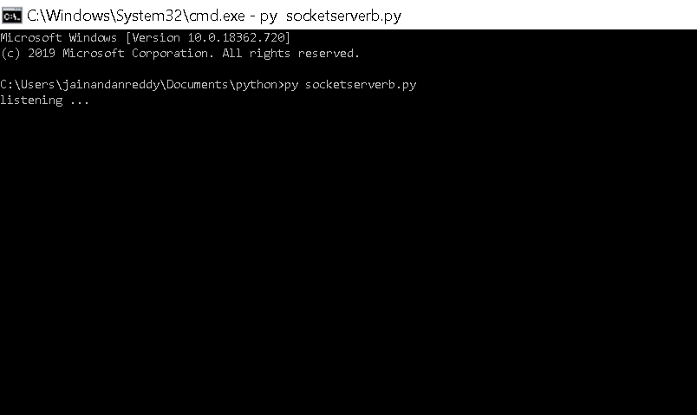

>>Now run the client code

>>It will ask to enter the file name.

>>Provided file name as input.txt

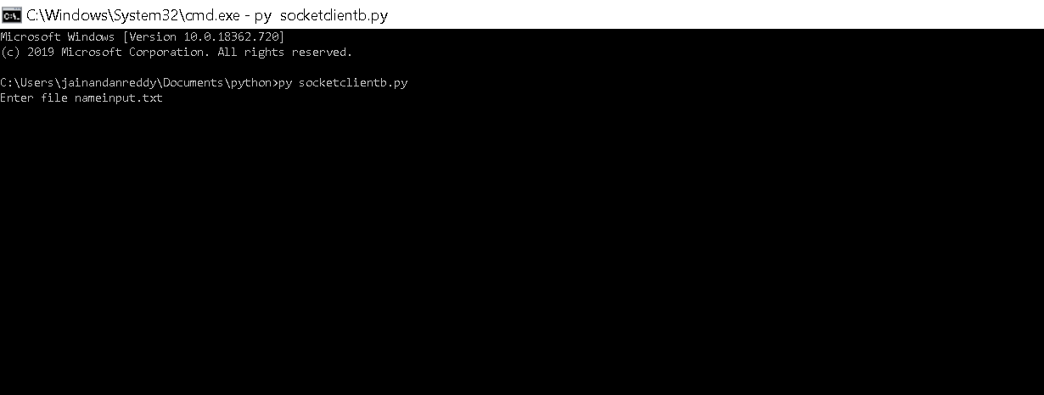

>>Server prints the file on the screen

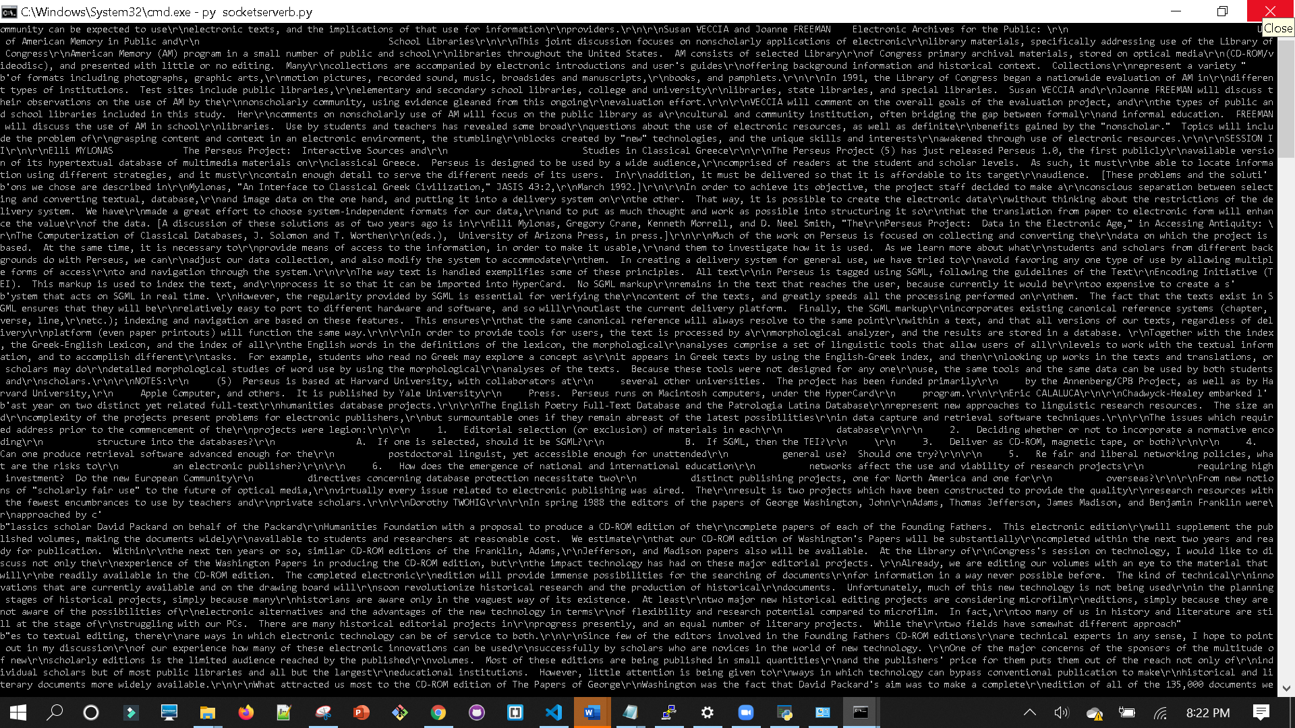

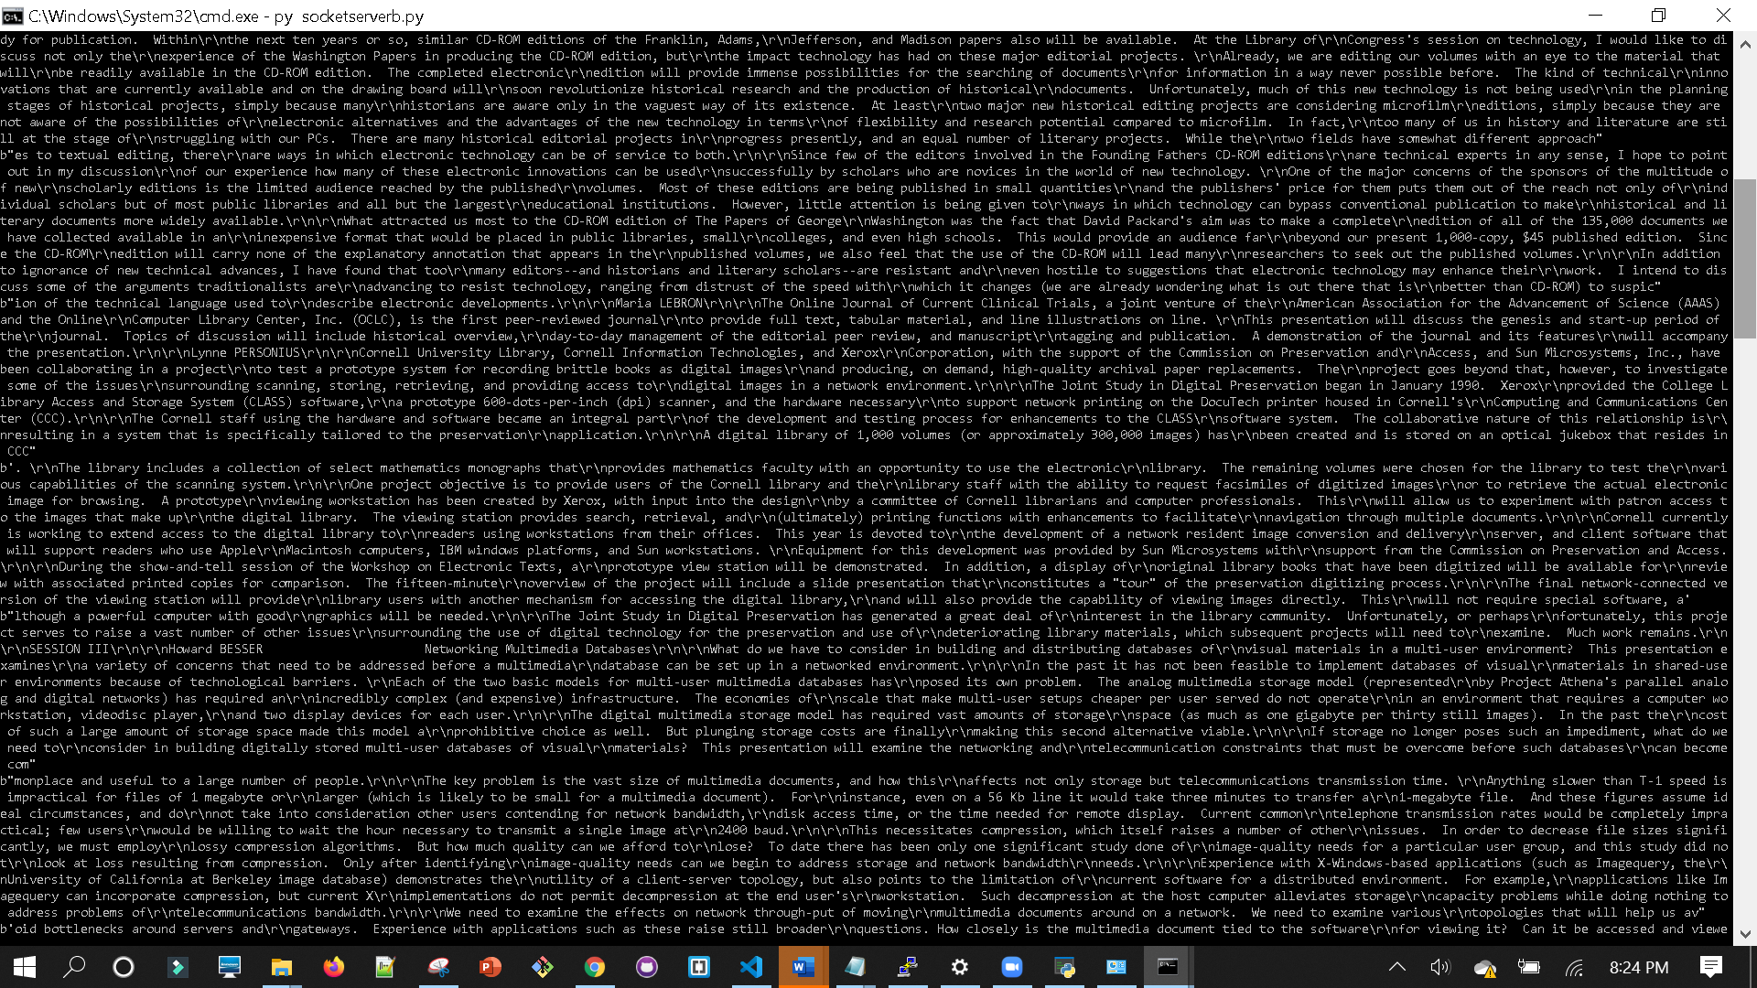

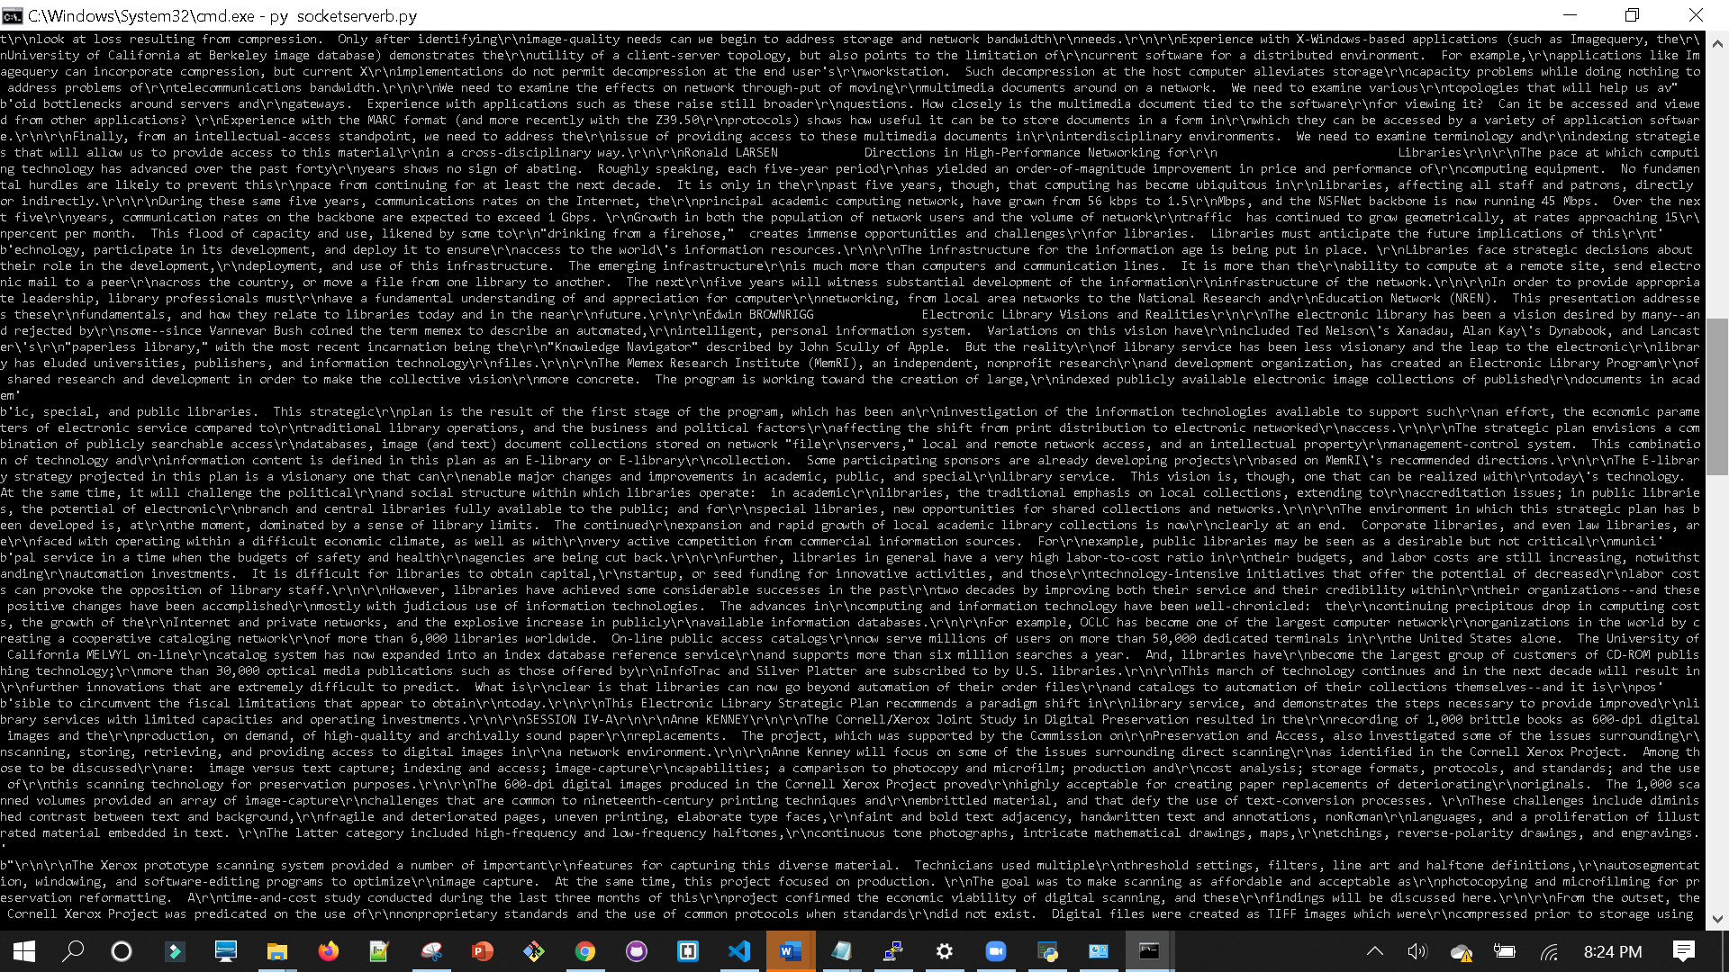

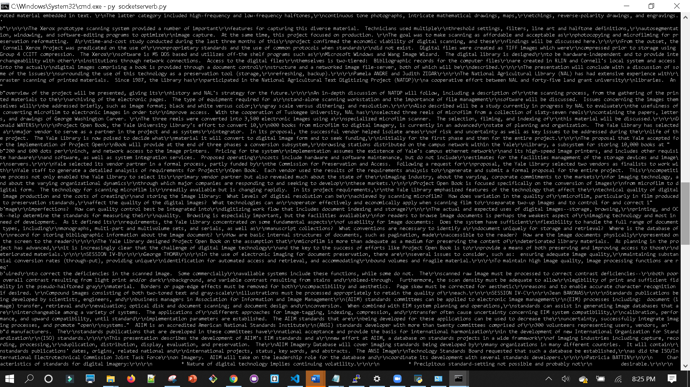

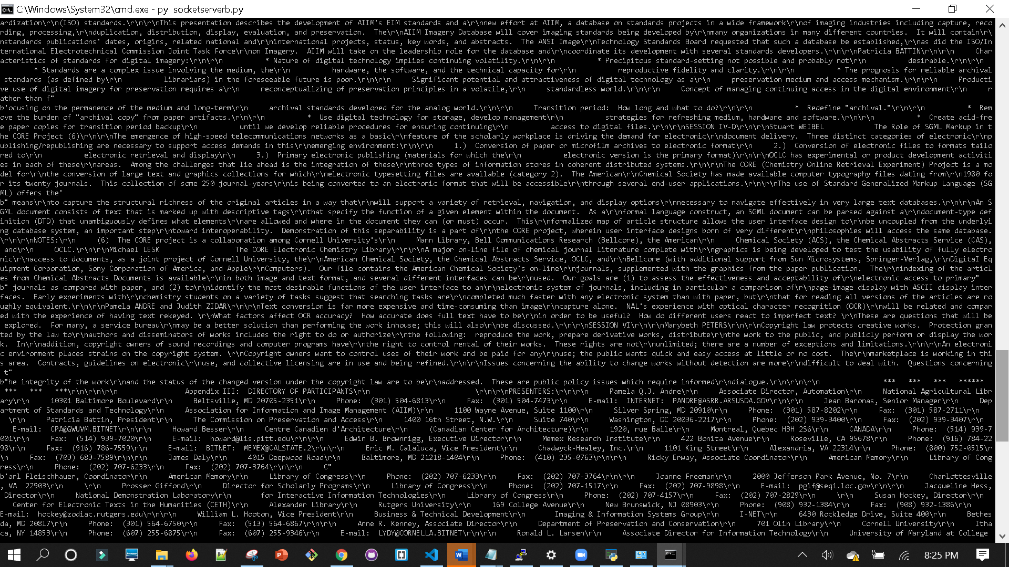

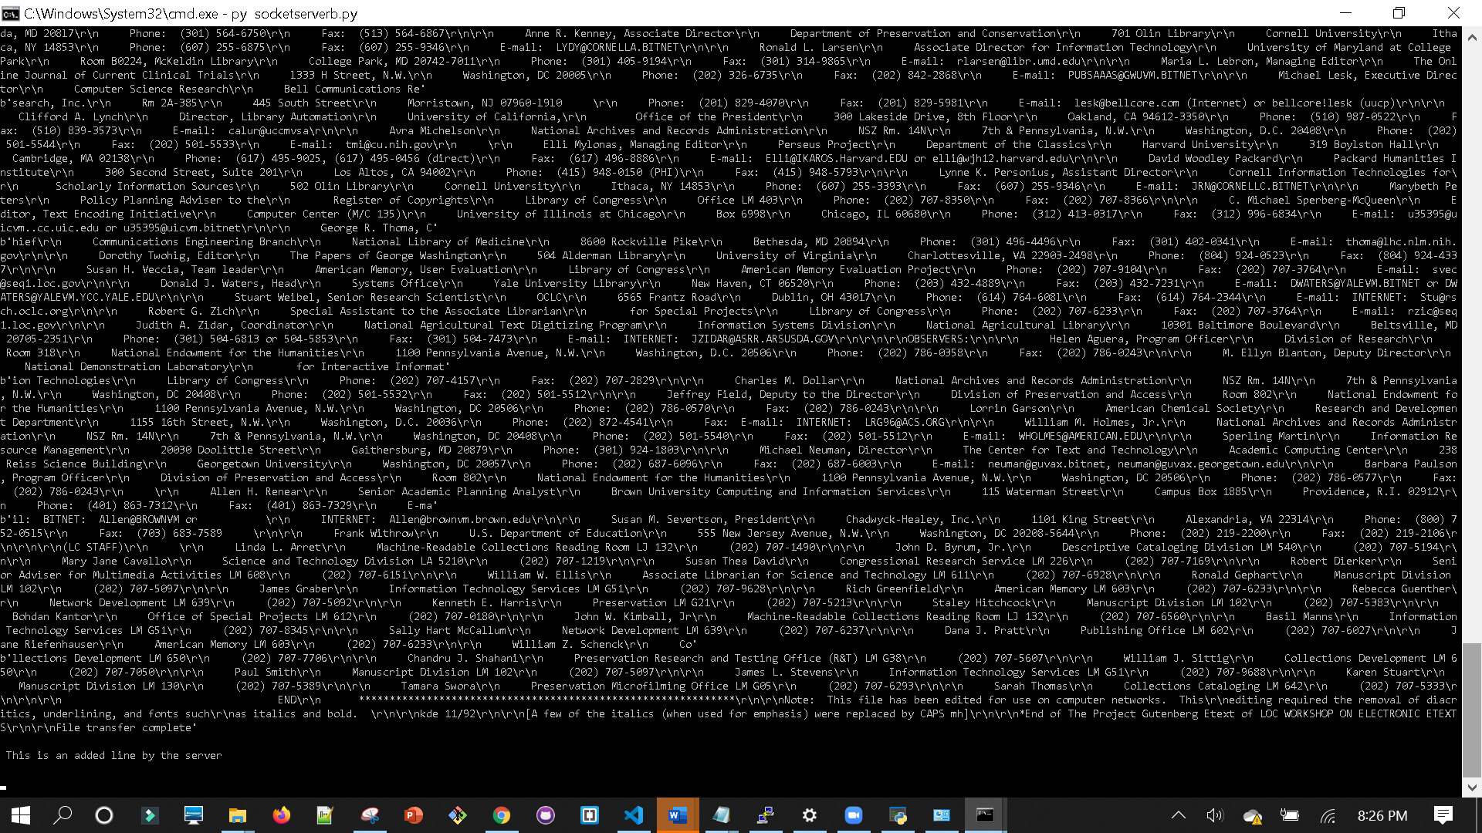

>>Server saves the file in a local system

>>File name: output.txt

>>Size: 10.01MB

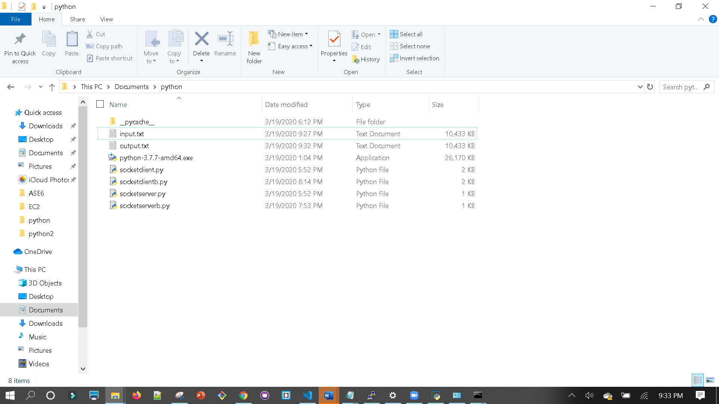

>>Server appends one more line which is “This is an added line from a server” to the file,

>>Server sent updated file back to the client

>>Client display the newly added lines from the server, not the entire file content.

>>Which is --- This is the added line by the server

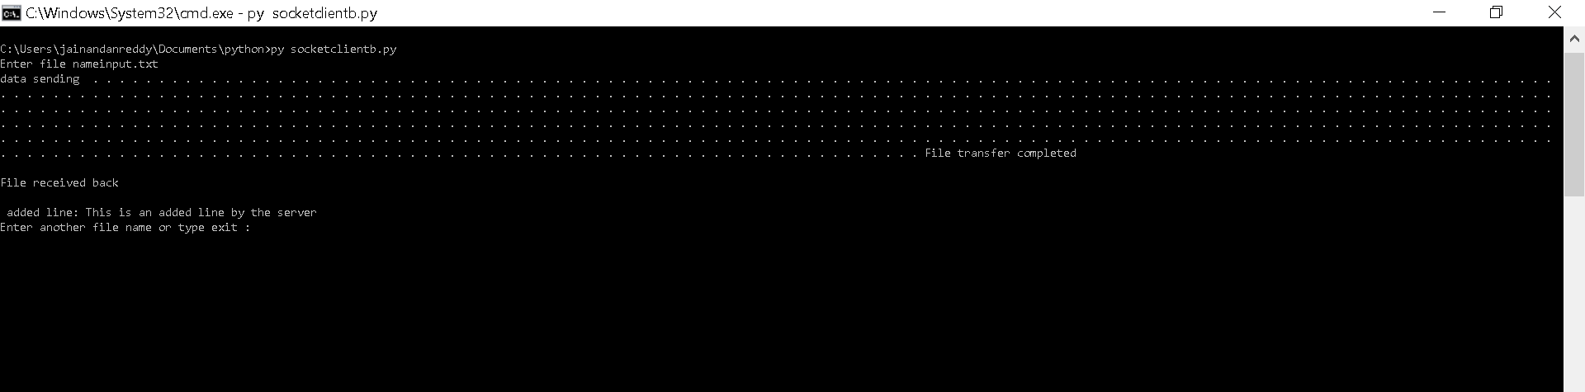

>>Output file-- we can see added line at the bottom

